**Following are the instructions to install SFML on windows:**

Open PowerShell (as Admin) and run the following commands:

wsl --install

wsl --update

wsl --shutdown

Open WSL from Start Menu and run the following commands:

sudo apt update

sudo apt install nautilus -y

**Ubuntu Commands for Setting Up Files (you can skip till here if you have Linux) :**

git clone https://github.com/mnmustafa1109/SFML-Workshop

cd SFML-Workshop

./install-dependency.sh

code .

**Once open in vs code:**

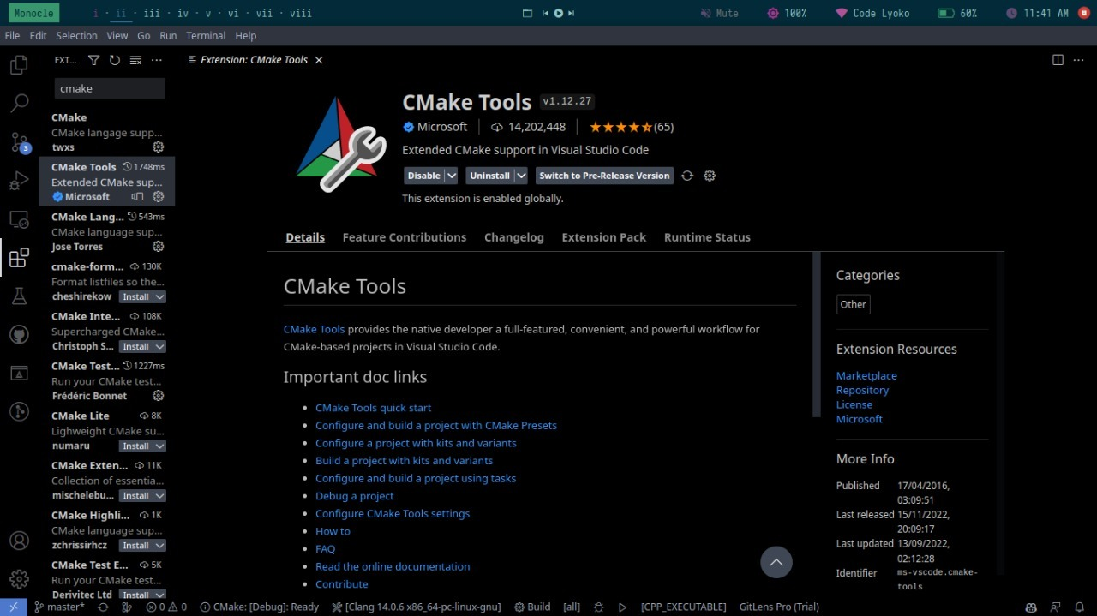

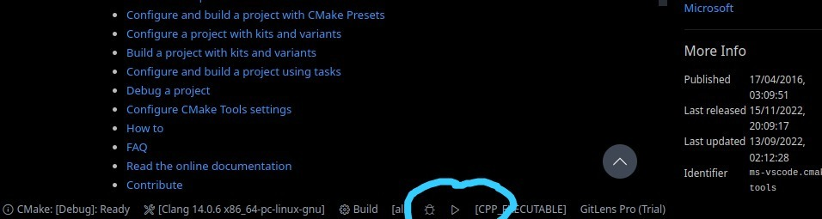

also, first time running extension, it will ask you to select a file, select "CMakeLists.txt" in the repository you just cloned ("SFML-Workshop" folder)

**If you dont want to use vscode (or have issues with the extension)**

mkdir build

cd build

cmake ..

cmake --build .

./app

***Credits to FGC Game Dev Team for this material and book***